Project Planning Phase
(Product Backlog, Sprint Planning, Stories, Story points)
Date Team ID
Project Name
01 November 2022 PNT2022TMID23094
AI-Powered Nutrition Analyzer for Fitness Enthusiasts

Product Backlog, Sprint Schedule, and Estimation:

Sprint

Sprint-1

Sprint-1 Sprint-1 Sprint-1

Functional Requirement (Epic)
Registration

Registration Registration Login
User Story Number USN-1

USN-2 USN-3 USN-4

User Story / Task

As a user, I can register for the application by entering my email, password, and confirming my password.
As a user, I will receive confirmation email once I have registered for the application.
As a user, I can register for the application through Google.
As a user, I can register & can log into the application through entering email & password.

Story Points

2

1

2

1

Priority

High

High Low Medium

Team Members

Gayathri.N

Vijayalakshmi.S
Varshini.A
Karthika.S

Sprint-2 Sprint-3 Sprint-3 Sprint-4 Sprint-4
Dashboard Storage
USN-5 USN-1 USN-2 USN-3 USN-4
As a user, I can access any of the options available there.
As a user, I can input any of the image of food in the upload field and obtain the results.
As a user, I will get the results of the image which is predicted by the model.
As a user, I can use diet charts and take tasks as my wish & get rewards.
As a user, I can purchase nutrition powders at affordable price.
- High

- High

2 Medium

1 High

1 Medium
Gayathri.N
Vijayalakshmi.S Varshini.A
Karthika.S
Gayathri.N

Project Tracker, Velocity & Burndown Chart: (4 Marks)
Sprint
Total Story Points
Duration
Sprint Start Date
Sprint End Date (Planned)
Story Points Sprint Release Date Completed (as on (Actual)
Planned End Date)
20
Sprint-1 Sprint-2 Sprint-3
Sprint-4
20
20
20
20
6 Days
6 Days
6 Days
6 Days
29 Oct 2022
03 Nov 2022
07 Nov 2022
14 Nov 2022
02 Nov 2022
05 Nov 2022
12 Nov 2022
19 Nov 2022
29 Oct 2022

Velocity:
Imagine we have a 10-day sprint duration, and the velocity of the team is 20 (points per sprint). Let’s calculate the team’s average velocity (AV) per iteration unit (story points per day)
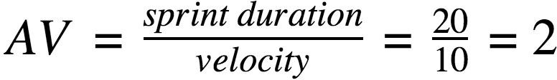

Burndown Chart:

A burn down chart is a graphical representation of work left to do versus time. It is often used in agile software development methodologies such as Scrum. However, burn down charts can be applied to any project containing measurable progress over time.

